Query optimisation and CTEs
Table of Contents
What is this assignment about? 2
Before you start 2
Questions 2
Submitting your assignment 3

What is this assignment about?
In this assignment, you will practice creating efficient queries to retrieve data from the football database. This assignment represents 5% of your CA marks.
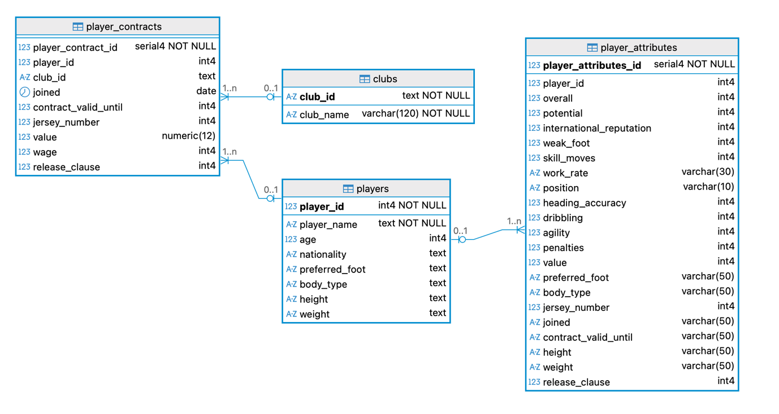

Before you start
If you do not have access to the football database, run the file football.sql.

Questions
Question 1 – Query optimisation (2 marks)
a) Write an SQL query that retrieves all values for all attributes on the table player_attributes.
b) Now, write an optimised version that:
- Selects only 3 (three) attributes
- Selects only the first 20 rows of the table
c) Compare how long it takes to run each of the two queries you wrote in parts A and B.

(Questions 2 and 3 are on the following page)

Question 2 – Subqueries x JOINs (2 marks)
a) Using a subquery (no JOINs), write a query that returns player_id and player_name for all players who have a contract.
b) Rewrite the same query using JOINs instead of a subquery.
c) Compare how long it takes to run each of the two queries you wrote in parts A and B.

Question 3 – Common Table Expression (CTE) (1 mark)
Write a query using a CTE that computes the average of the attribute overall per club. Run a SELECT query to retrieve the data from the CTE, showing two columns: the club name and the average overall attribute.

Submitting your assignment
Make sure you submit your assignment by the end of the lab session and demonstrate it to your lab instructor.

